

**Department of**

**Computer Science and Engineering**

**Lab Report - 06**

Course No.              : CSE-308

Course Title             : System Analysis and Design Laboratory

Submitted By         :

  Name : 1 . Tasmim Sultana(129)

  2 . Fatama Jannat Tisha (131)

                                   3 .  Kamelia Zaman Moon (299)

                               4  .Umma Salma (302)

                                   5 . Sabrina Afrin Toma (304)

         Session        : 2017-18

         Semester     : 3rd year 1st Semester

Date            : 19-07-2020

Submitted To:

Md Musfique Anwar

         Associate Professor, Department of Computer Science and Engineering

         Dr. Md Humayun Kabir

Professor, Department of Computer Science and Engineering

Jahangirnagar University, Savar

**Experiment No:** 06

Title: E-R diagram and database schema for online class and examination system.

**Objectives:**

The entity–relationship (E-R) model is a high-level data model. It is based on a perception of a real world that consists of a collection of basic objects, called entities, and of relationshipsamong these objects.

A database schema is the skeleton structure that represents the logical view of the entire database. It defines how the data is organized and how the relations among them are associated. It formulates all the constraints that are to be applied on the data.

**Procedure:**

Entity sets, their attributes and primary keys:

Administrator: ;

User: id, name, password;

Blog: topicName, topicLink;

Student: stu_id, stu_name, email, course_id;

Teacher: teacher_id, teacher_name, email, phone_no, subj_name;

Exam: exam_id, start_time, end_time;

Result: stu_id, marks, passing_year;

Materials: material_id;

Topic: topic_name;

Attendance: stu_id, name, date;

Notice: date, title;

Practice_exam: question_id, question, options;

Question_PY: question_id;

Chat: person_id;

Group_chat: group_name;

Relationship sets and their attributes (descriptive):

adds,

creates,

views,

gives,

practices,

prepares,

evaluates,

continues,

takes,

uploads,

discusses.

**Entity-Relation (E-R) Diagram:**

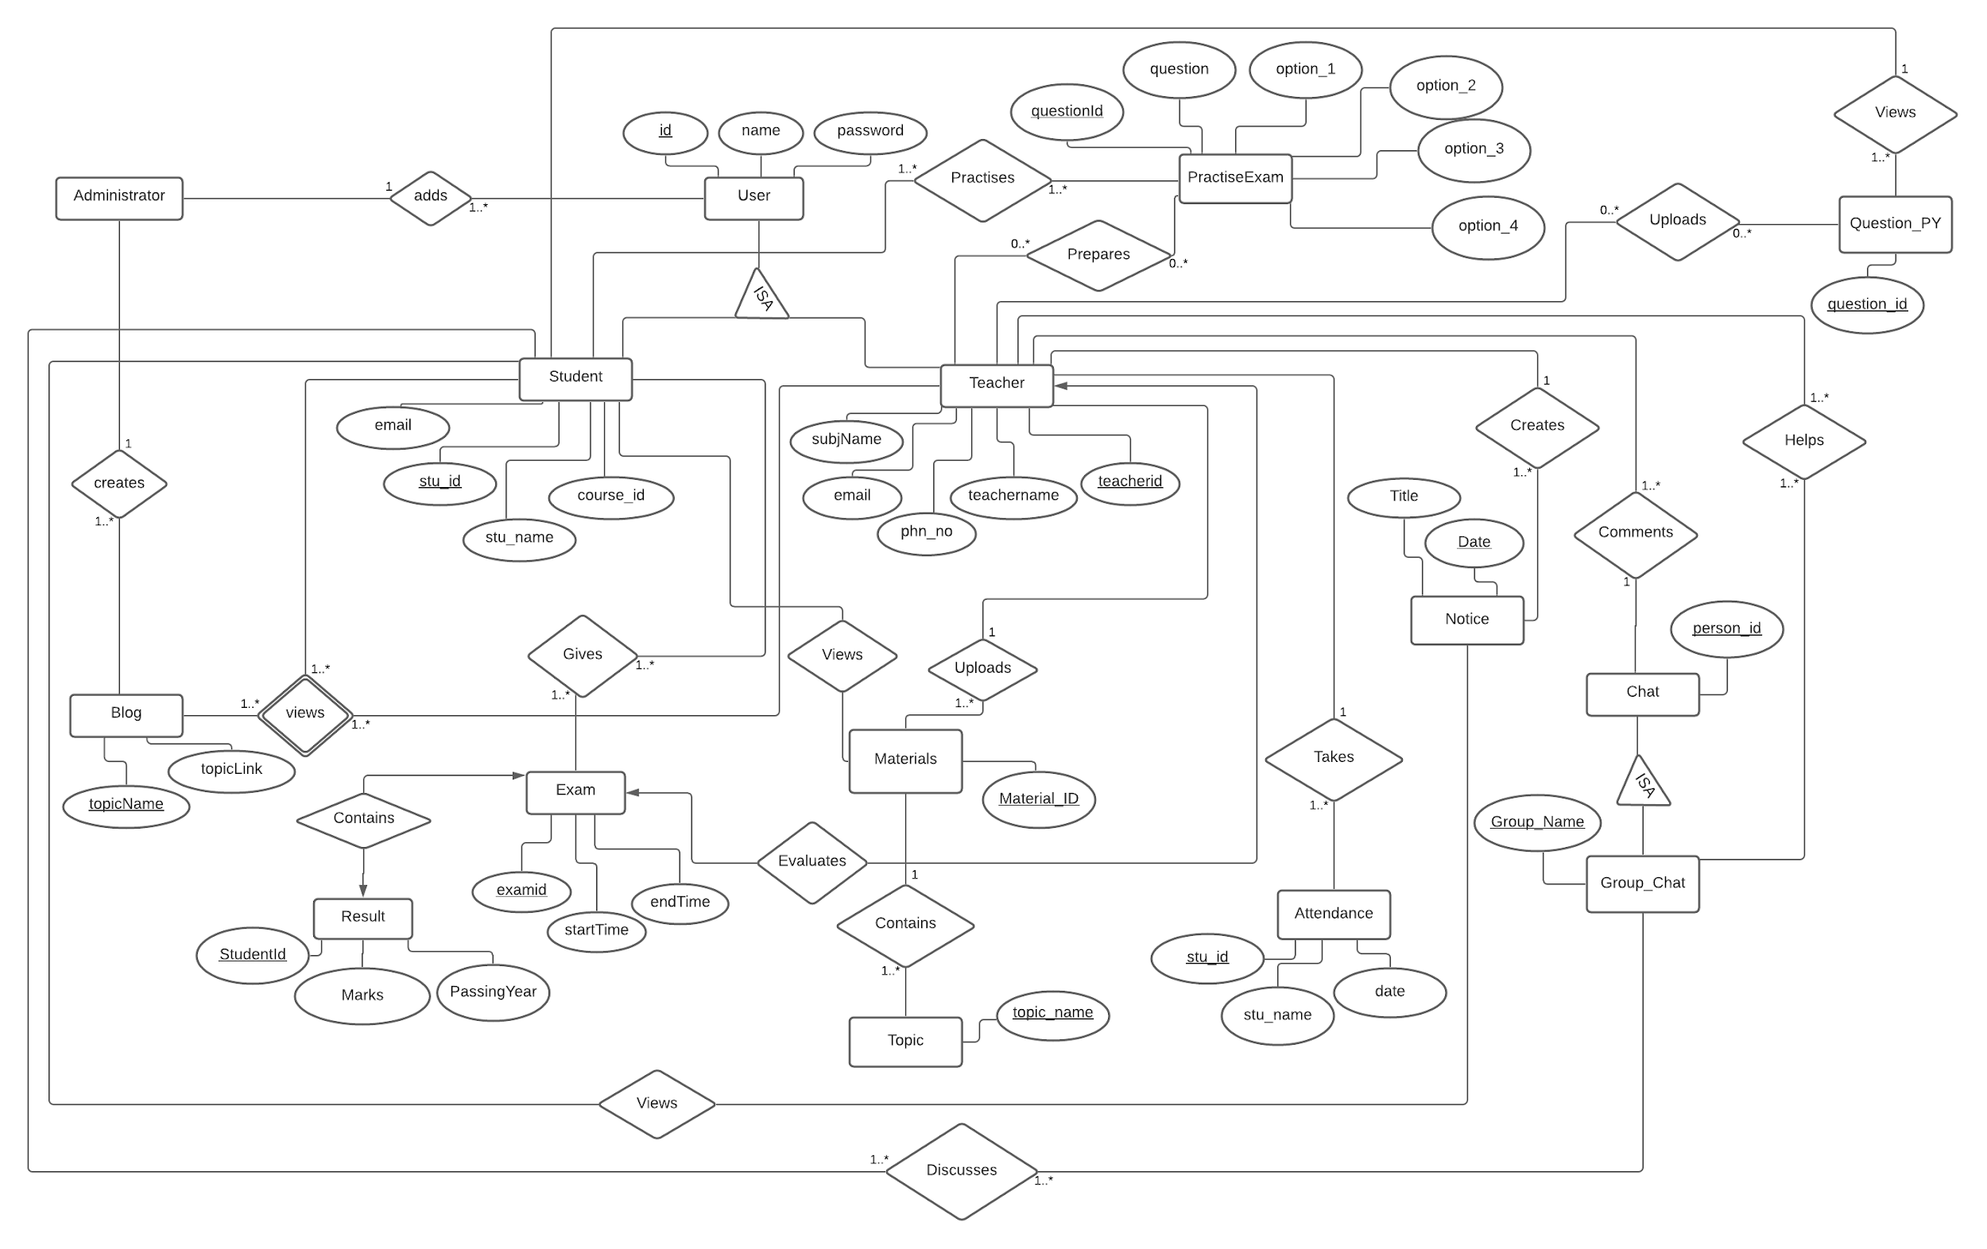

**Database-schema:**

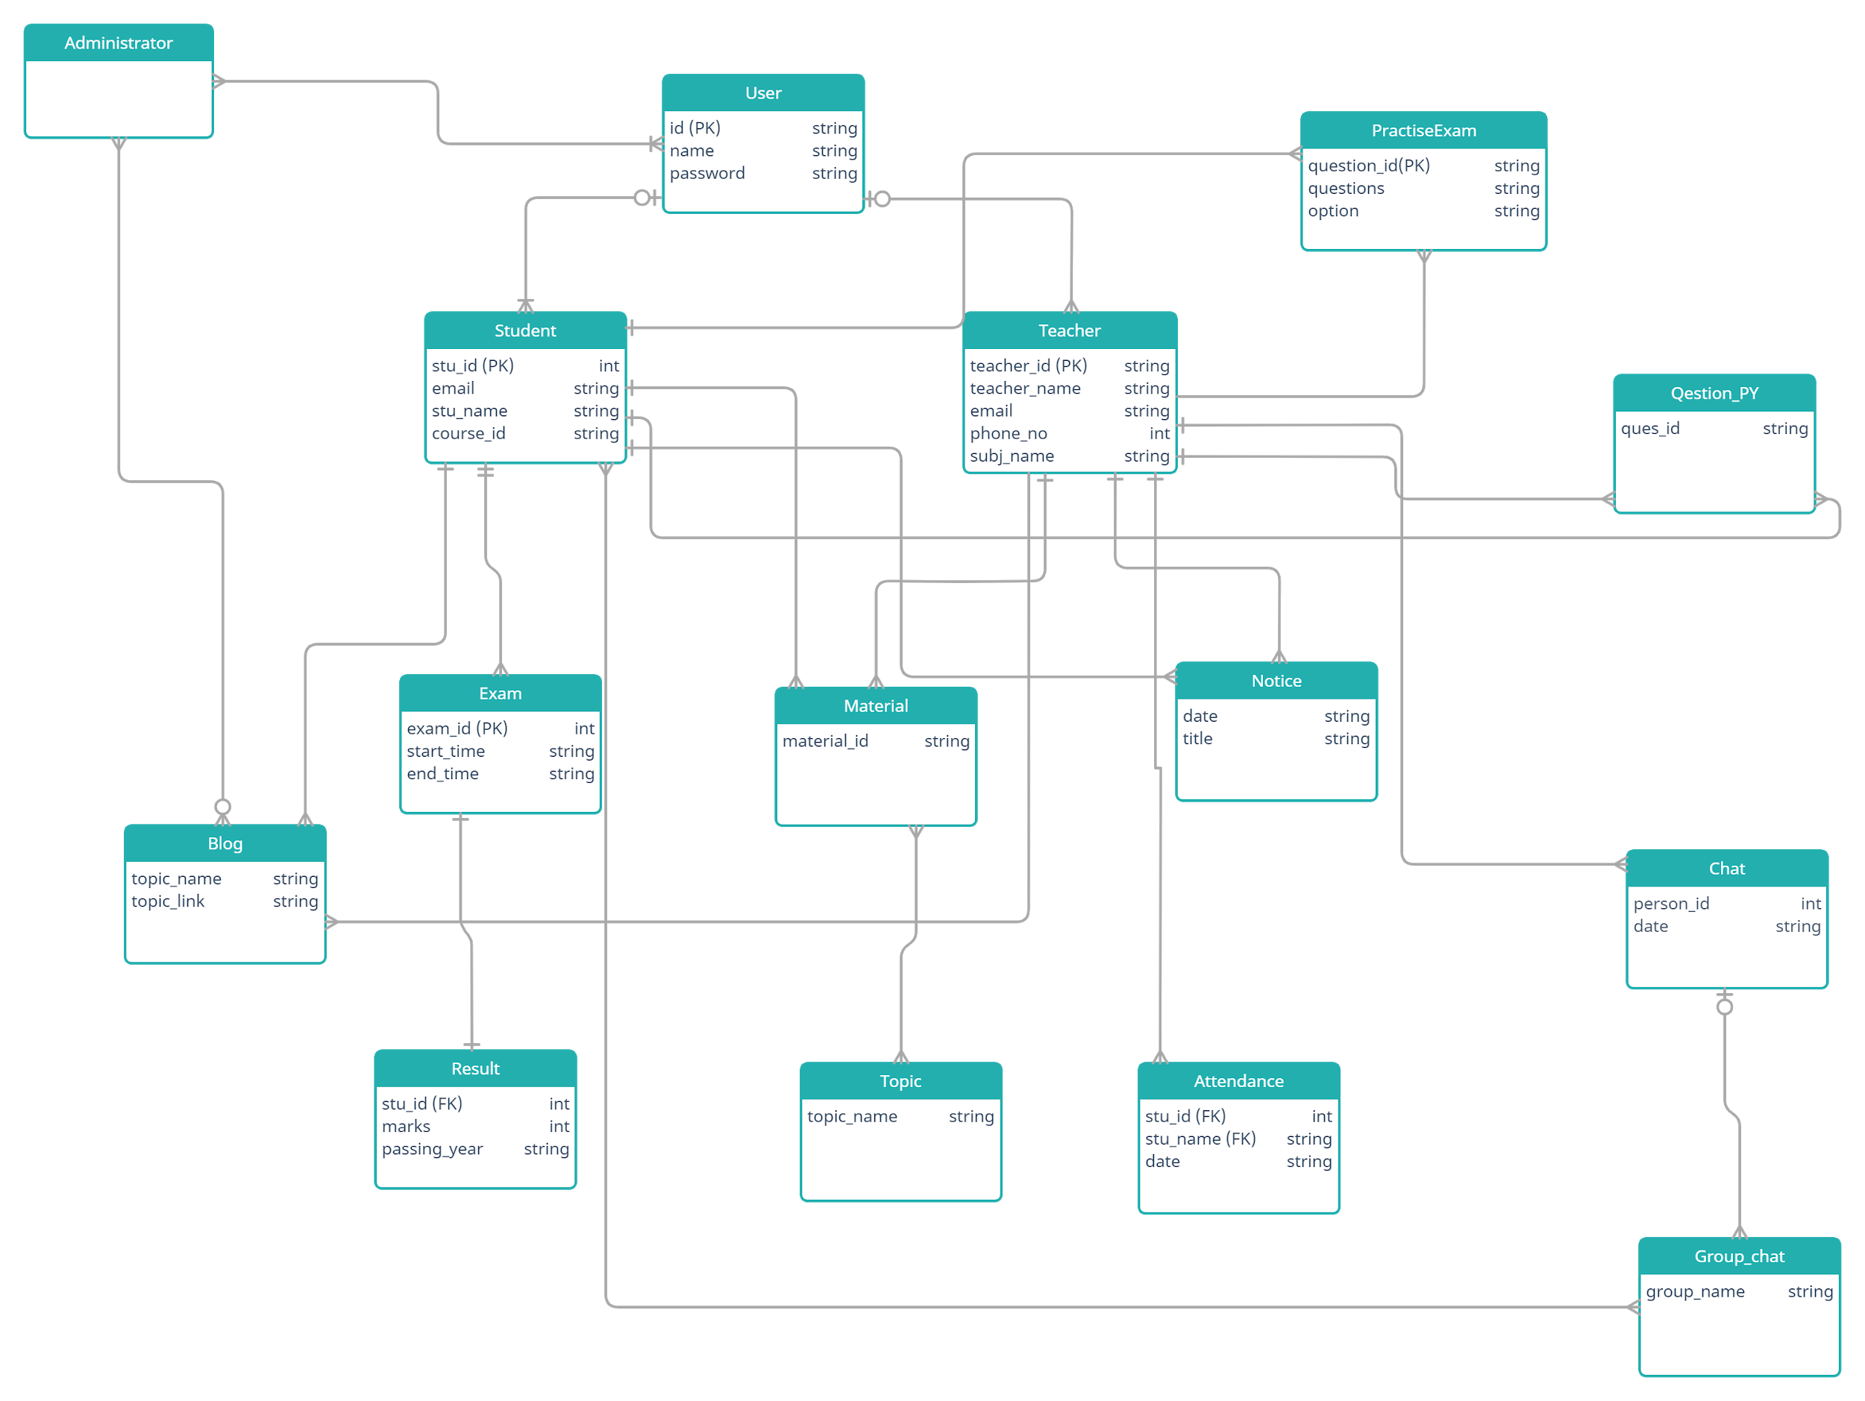

**Discussion:**

By this experiment, we have learnt that, an entity–relationship model describes interrelated things of interest in a specific domain of knowledge and a database schema defines its entities and the relationship among them. It contains a descriptive detail of the database, which can be depicted by means of schema diagrams. It’s the database designers who design the schema to help programmers understand the database and make it useful.